**INSTRUCTOR NAME: ERSAN CAM**

**MARKS ALLOTTED: 100 (%70 back end + %30 Front End GUI)**

**WEIGHTING: 15%**

**General Instructions :**

You can use any Web based front end programming tool which can connect to our database in Lab or your own database

* Clean Coding, Interaction with Database (Connectivity, Login page etc ) , GUI features (Drop down menu , list box, Radio boxes etc if needed) and actual Presentation skills will be evaluated during presentation time.
* Expectation is that everyone in the team shares responsibility. If one person writes some stored procedure and the other one writes function , one or two can work on GUI same as in real life environment.
* **Presentation will be on last day.**
* Make power point presentation and do share with instructor in advance. Instructor will open presentation for you to present in front of class or you can plug your own laptop.
* If you want to use your own laptop , it is your responsibility to test connectivity of Projector otherwise do send all files and presentation to instructor and do DEMO from Instructor’s computer.

**Marking guidelines**

**Back-end programming (Up to 70 points)**

All the procedure ,function, triggers must be cleanly compiled with no errors. Tested on SQL Developer

You will be collecting points by doing successful Demo and test in front of Instructor and audience

**2-Front end GUI effectiveness (0 up to30 pnts)**

How user friendly is your GUI? Is it just basic & quickly written-basic but functional GUI or efficient and colorful/fancy GUI ?

Presentation skills (Eye contact with audience - Voice control - body gesture etc (Do some research on basic presentation skills )

**Try to create a Dream Home Real Estate application Menu like below or use your imagination. You are completely free to design any shape of form for the menus**

|  |  |  |
| --- | --- | --- |
| **Staff Main Menu** | **Branch Main Menu** | **Client Main Menu** |

**Please Note that all the table names are under DH_XXXX Schema in our sample databases**

**Staff Hiring / Terminating / Update/ Info Screen**

**Task1-1**

Create a Procedure called Staff_hire_sp which accepts 9 parameters

Once these values come as parameter then procedure BEGIN END should have simple INSERT statement

BEGIN

**INSERT INTO** dh_staff ( col1, col2, col3, ….., col9 )

**VALUES** (p_staffno, p_first_name, p_last_name ,,,,,,,,,,,,)

COMMIT;

END;

**TEST:** You can test your procedure in SQL developer to make sure it works and insert new dh_staff record to table

**Task1-2 - GUI work**

Create a Page (Form) for Staff Hiring activities UNDER Staff Main Menu

|  |  |  |  |  |  |  |  |  |
| --- | --- | --- | --- | --- | --- | --- | --- | --- |
| **Staff Hiring Form**   |  |  |  | | --- | --- | --- | | **First Name :** | **Last Name:** | **Position**: |  |  |  |  | | --- | --- | --- | | **BranchNo: B305** | DOB: 10/10/1980 | **Salary** : |  |  | | --- | | **Telephone**: **Mobile**: |  |  | | --- | | Email : |   Cancel  Hire |

In the form above you can see entry edit boxes such as phone or salary. They are simple edit boxes and when user enter these values they will be passed to **staff_hire_sp** procedure.

Once you collect all this information from front end and user click on at the bottom, black border button called Hiring then send them all as INPUT parameter to your procedure and make sure staff is hired by listing it at the bottom

Blue border box is for cancel option (optional)

**Task 1-3**

Under **Staff Main Menu** , create a link to list and Update all or any one the staff record.

Make a form to list all staff like excel grid format on the page and then let end user edit SALARY or PHONE or EMAIL information not any other info just any of these 3.

If any one of this info or all of these 3 info got change by end user then accept the new value and send to database as UPDATE COMMAND and replace old value with new one in **dh_staff** table.

*Sample :*

*UPDATE DH_STAFF SET SALARY= <new salary> WHERE staffno = ID from the form selected -highlighted record line*

It is up to you to create a procedure for this or simply use front end GUI capability to do list of all staff and edit in place on the form. Either way is OK.

**Note:**

Some web designers choose to have one single / same GUI doing all these different functionalities.

One for Entering new Staff information

One for Updating Staff details (except Staff ID)

And also in the same page you should list all the current employee as list at the bottom part of page

It is Up to you how you want to design the page(s) . You can create several different GUI pages doing each action described above or have one page and do multiple tasks in it.

**HINT for Dropdown Menu item if you like to add to your design**

As example, here below you can see one Dropdown lookup table box

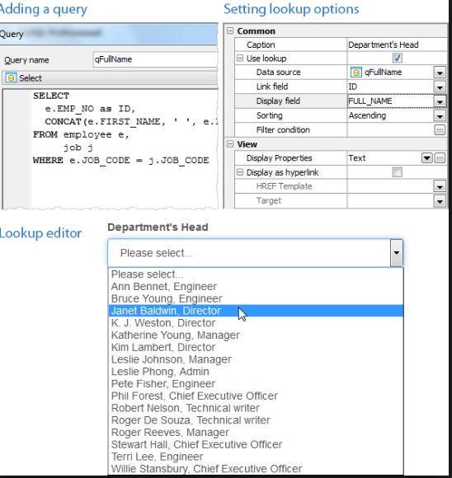

**Task 2: BRANCH related activities (BRANCH menu)**

**Task 2-1** **Get Branch Address**

Under the BRANCH MAIN menu create a link called **Identify Branch address**

In this link or (page or form) idea is End user will enter BRANCHNO let’s say B002 and form will bring accurate **street and city address together**  from dh_branch table

There will be one Edit box to accept BranchNo from end user

To do that, you can either use FUNCTION or Front end SQL Select

A ) create a Function called **get_branch_Address**  (accept one INPUT parameter as **staffno** varchar) and RETURN VARCHAR

Function will get staffno as INPUT and search this in WHERE condition from DH_STAFF table and bring street|| city info back to page (Form)

**Or**

B) you don’t need to create function, you can simply use FRONT END capability to write simple SQL Select statement and return street||city from the database.

**Task 2-2 - Allow end user to change BRANCH ADDRESS**

In this page (form) you will bring and list all the BRANCH details /columns from database DH_STAFF table to web page same as Excel Grid and then you can allow user to update (edit ) any values other than BRANCHNO.

-Let’s say end USER picked B004 record and edit street as 35 Raven Street or London City then get these changes and update in the database DH_BRANCH table permanently with commit

-To do that ,again you can create Function or Store procedure to do this UPDATE command. You can accept any edit box new value as parameter and call Function or procedure and ask them to do it.

-Or simply use front end edit/update capability on one record. UP TO YOU

-In each method please DO NOT FORGET TO ADD COMMIT; command after UPDATE command.

**Task 2-3 Open a BRANCH**

Create this procedure in the database at first and test this procedure in SQL developer. Show your test work to us during the demo (I am sure you would have same procedure already as part of in class practice)

CREATE or REPLACE PROCEDURE new_branch (p_branchno in datatype, p_street in datatype , p_city in datatype, p_postcode in datatype)

IS

Scalar variables -- IF needed

BEGIN

INSERT INTO dh_staff ( col1, col2 , col4) VALUES ( p_branchno, p_street , p_city , p_postcode );

Commit;

END ;

**Task 3 – Client Menu menu activities**

**Task 3.1 – Create a web Form to register new client**

Similar to Task 1-2

**Task 3.2 – Create a web Form to update client**

Similar to Task 1-3